**LITERATURE SURVEY**

A literature review surveys books, scholarly articles, and any other sources relevant to a particular issue, area of research, or theory, and by so doing, provides a description, summary, and critical evaluation of these works in relation to the research problem being investigated.

**PROBLEM IDENTIFICATION**

### This project Industry-Specific Intelligent Fire Management System

is intended to provide information about the fire zones in a particular region by alerting through continuous monitoring of the location. Key benefits of the application are monitoring people's activity and alerting them of their safety movements.

**PROBLEM SOLUTION**

* The smart fire management system includes a Gas sensor, Flame sensor and temperature sensors to detect any changes in the environment.
* Based on the temperature readings and if any Gases are present the exhaust fans are powered ON.
* If any flame is detected the sprinklers will be switched on automatically.
* Emergency alerts are notified to the authorities and Fire station.

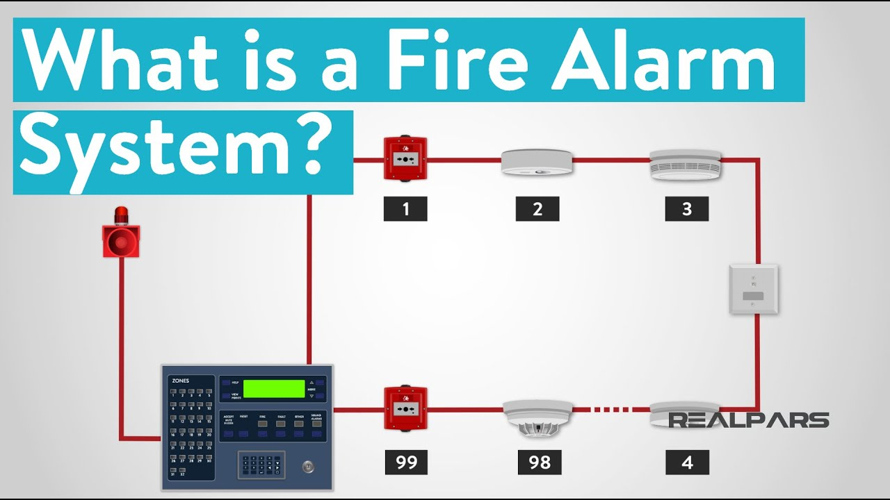

**REFERENCES**

<https://www.ncbi.nlm.nih.gov/pmc/articles/PMC6679255/>

https://www.ncbi.nlm.nih.gov/pmc/articles/PMC6679255/